Georgia Rural AP STEM Initiative – Round 2

Eligibility Criteria

High-Need: LEAs located counties designated as Tier 1 or Tier 2 based on the Georgia Department of Community Affairs’ annual job tax credit tiers are considered high-need. These counties represent the counties with high unemployment rates, low per capita incomes, and high percentages of residents whose incomes are below the state poverty level.
Rural: LEAs are considered rural for the purposes of this grant if they serve fewer than 30 students per square mile. These LEAs must spend proportionally more funds per pupil since they serve a more dispersed population and do not have the economies of scale of larger districts.
**Note: The three State Schools are also eligible. In addition, state charter schools that are located in a Tier 1 or Tier 2 County and have an attendance zone in which all LEAs are eligible for the grant are also eligible. Using these criteria, the LEAs on the map and listed below are eligible.
Georgia Rural AP STEM Initiative Eligibility Map
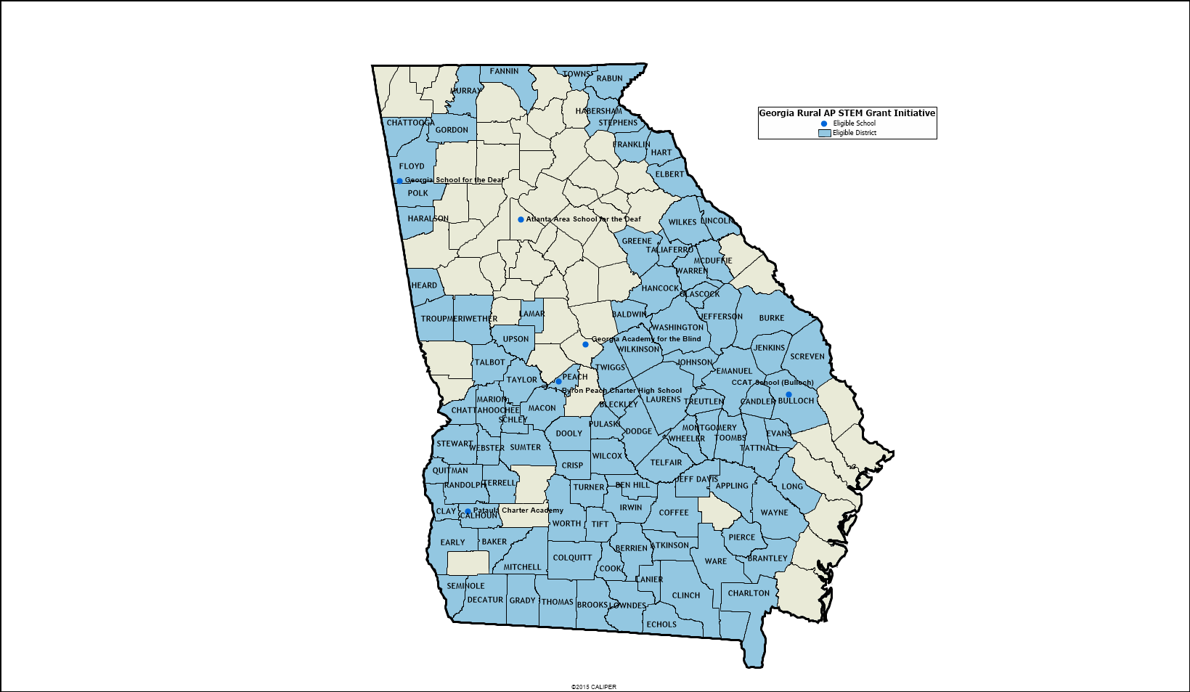

Georgia Rural AP STEM Initiative Eligibility List
Atkinson County | Dodge County | Jeff Davis County | Quitman County | Terrell County
Baker County | Dooly County | Jefferson County | Rabun County | Thomaston-Upson County
Ben Hill County | Early County | Jenkins County | Randolph County | Tift County
Berrien County | Echols County | Johnson County | Schley County | Toombs County
Bleckley County | Elbert County | Lamar County | Screven County | Towns County
Brantley County | Emanuel County | Lanier County | Seminole County | Treutlen County
Brooks County | Evans County | Laurens County | State Charter School – Byron Peach Charter High School | Troup County
Bulloch County | Fannin County | Lincoln County | State Charter School – CCAT School (Bulloch) | Turner County
Burke County | Floyd County | Long County | State Charter School – Pataula Charter Academy | Twiggs County
Calhoun County | Franklin County | Lowndes County | State Schools – Atlanta Area School for the Deaf | Ware County
Candler County | Glascock County | Macon County | State Schools – Georgia Academy for the Blind | Warren County
Charlton County | Gordon County | Marion County | State Schools – Georgia School for the Deaf | Washington County
Chattahoochee County | Grady County | Meriwether County | Stephens County | Wayne County
Chattooga County | Greene County | Mitchell County | Stewart County | Webster County
Clay County | Habersham County | Montgomery County | Sumter County | Wheeler County
Clinch County | Hancock County | Murray County | Talbot County | Wilcox County
Coffee County | Haralson County | Peach County | Taliaferro County | Wilkes County
Cook County | Hart County | Pierce County | Tattnall County | Wilkinson County
Crisp County | Heard County | Polk County | Taylor County | Worth County
Decatur County | Irwin County | Pulaski County | Telfair County

